How to Backup Satellite Parameters and Channels for Openbox X6

- Set the satellite parameters on a X6 box, search the required channels
- Plug in USB disk, backup the parameters and channels, upgrade as below steps
Image 1
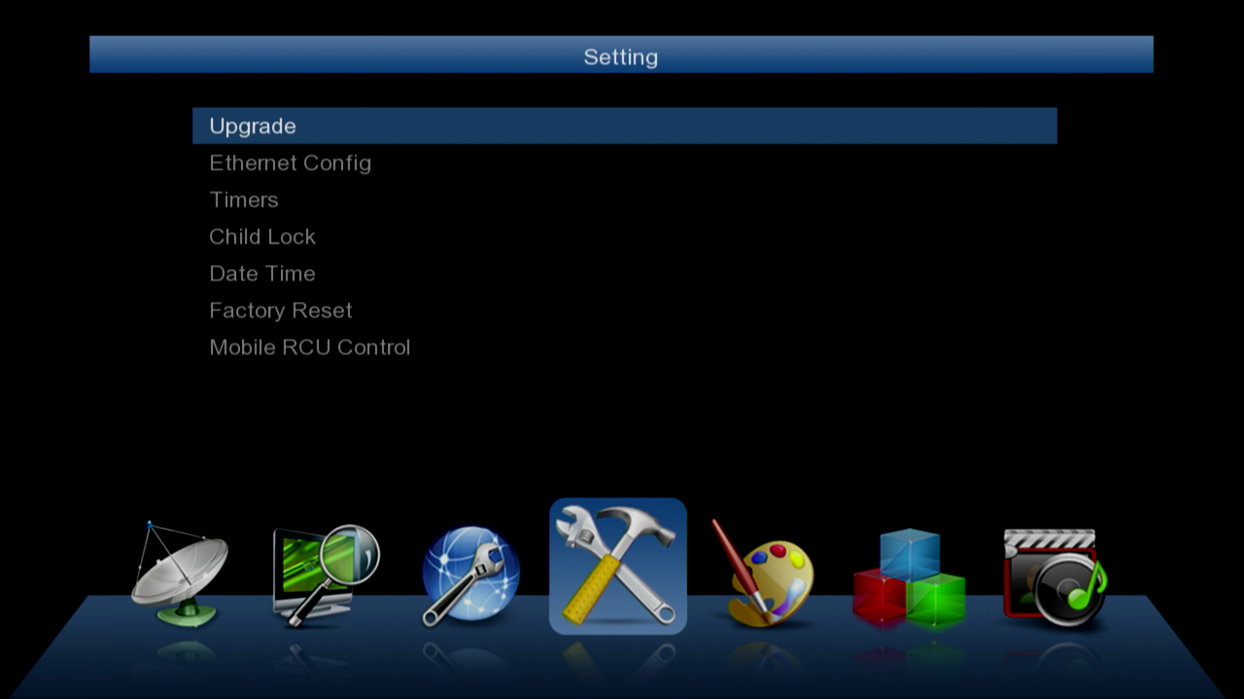
Image 2
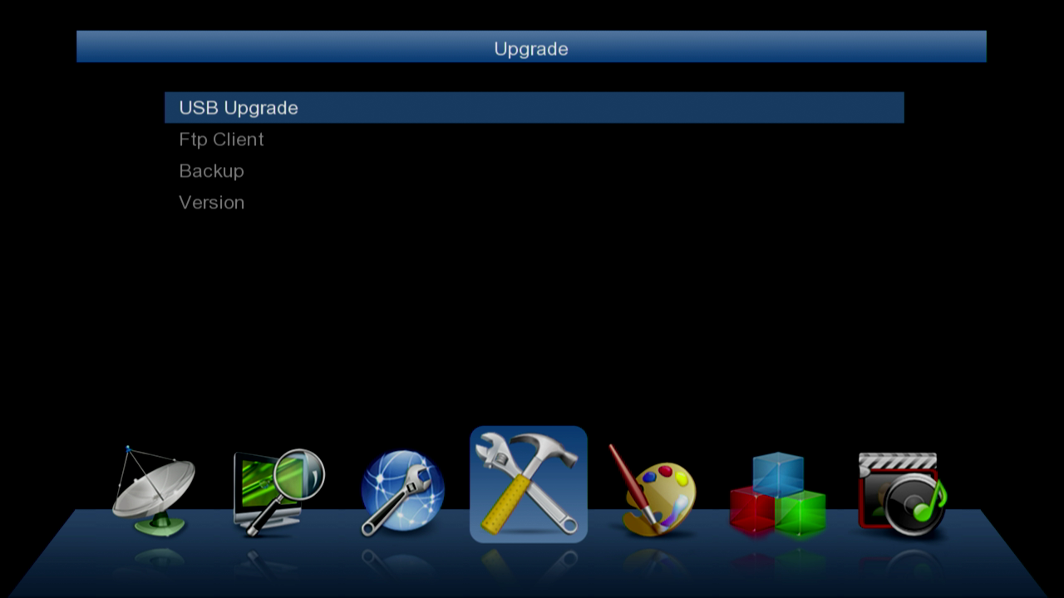

Image 3
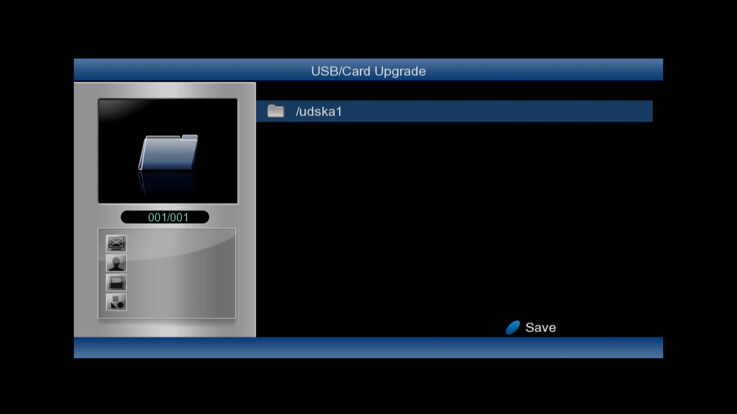

Enter the USB disk root directory, press the BLUE button on the remote controller, save data as below
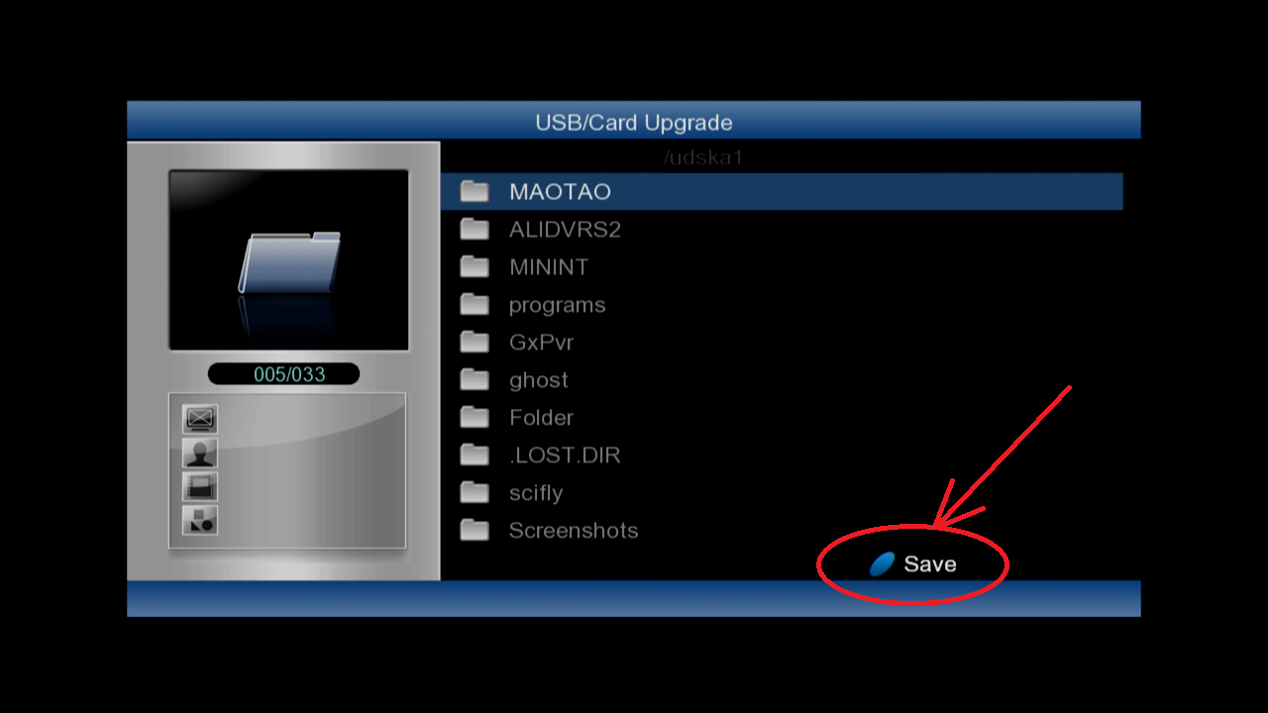

db.bin shows, backup succeed
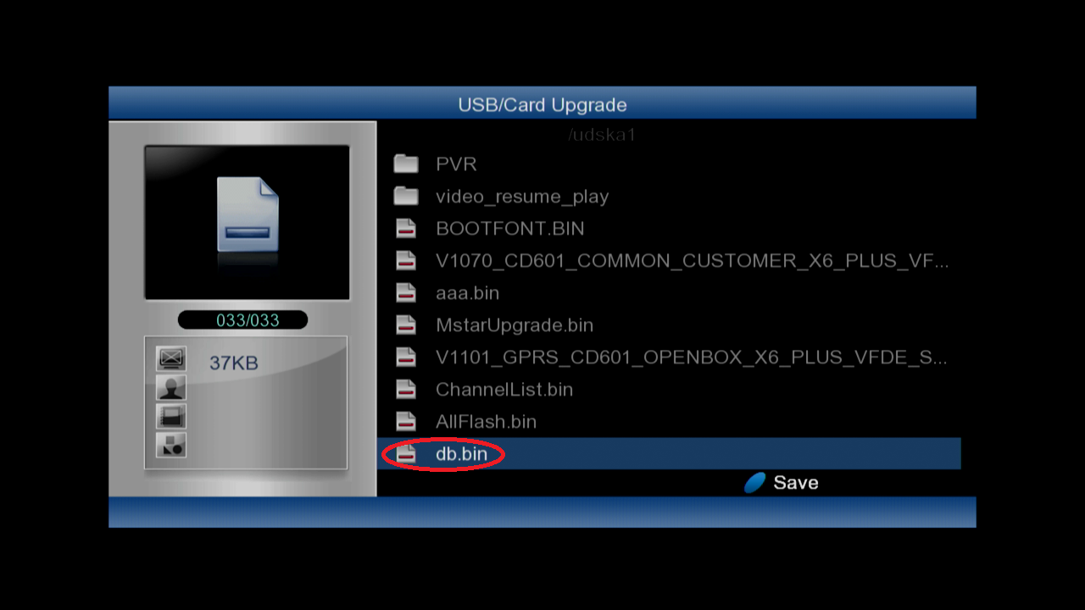

- If need update db.bin to other box, plug the U-disk with db.bin to the box, upgrade as above image1, image2, image3
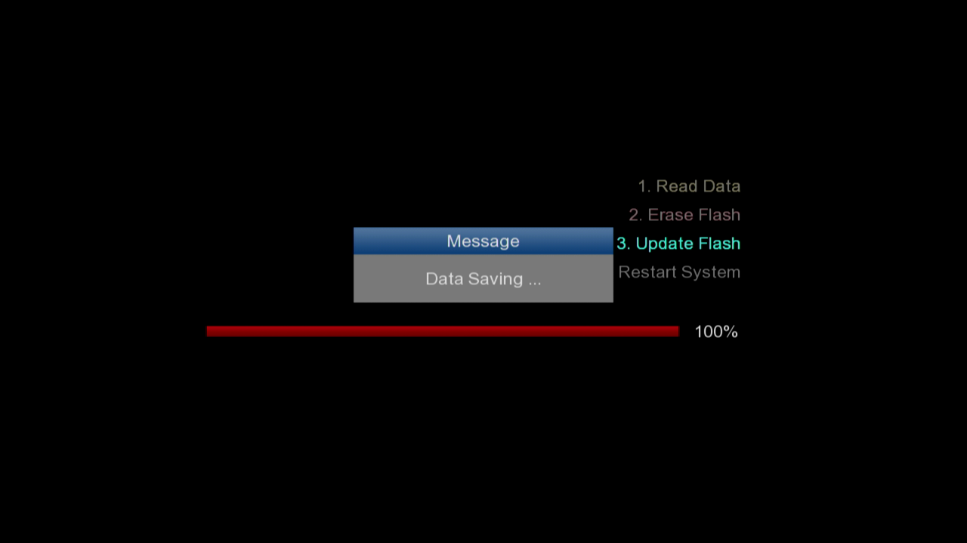
Reboot the box, the backup parameters and channels will be available on this box.

